Bahrain: Open letter to Danish Prime Minister to take immediate action to free Abdul-Hadi Al-Khawaja

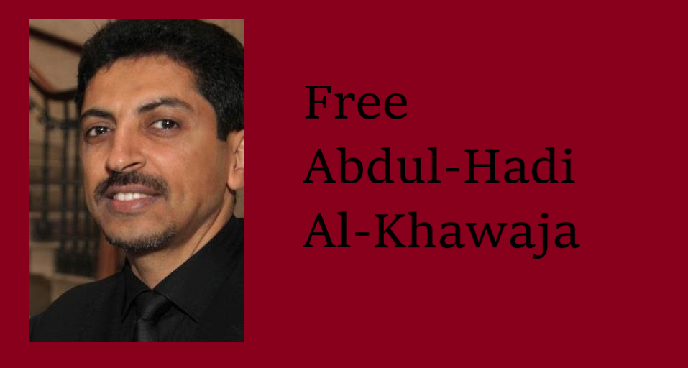

22-January-2021

Dear Prime Minister Mette Frederiksen,

We the undersigned, more than 100 organisations from around the world, are appealing for your assistance to secure the release of prominent human rights defender and dual Danish-Bahraini citizen Abdul-Hadi Al-Khawaja from prison in Bahrain, where he is serving a life sentence for his peaceful political and human rights activities in violation of his right to freedom of expression. As he completes the tenth year of his imprisonment, we appeal to you directly as head of the Government of Denmark to renew and strengthen efforts to ensure his immediate and unconditional release so he can be reunited with his family and receive much needed medical treatment and torture rehabilitation in Denmark.

An internationally-recognised human rights defender, Al-Khawaja is the co-founder of both the Gulf Centre for Human Rights (GCHR) and the Bahrain Center for Human Rights (BCHR), for which he was also the former President, and he worked as MENA Protection Coordinator for Front Line Defenders from 2008 until early 2011.

He was arrested on 9 April 2011 for his role in organising peaceful protests to defend people’s rights and to demand political reform during the popular movement which began in February 2011. Security forces violently arrested Al-Khawaja, as detailed in a report by the Bahrain Independent Commission of Inquiry (BICI), published in November 2011 at the request of the Bahraini king. It says, “Immediately after the arrest, the detainee received a hard blow to the side of his face, which broke his jaw and knocked him to the ground. He was taken to the Ministry of Interior (MoI) clinic and then the Bahrain Defence Forces (BDF) Hospital where he had major jaw surgery for four broken bones in his face.” Al-Khawaja was subjected to additional severe physical, psychological and sexual torture in detention (as described in the BICI report, as Case No. 8.)
Security officers tortured Al-Khawaja directly after his major jaw surgery, while blindfolded and restrained to a military hospital bed, which forced the doctor to ask the security officers to stop as it would undo the surgical work. Almost ten years later he still suffers from chronic pain and requires additional surgery to remove the metal plates and screws that were used to reattach his jaw. Despite continuous requests, including through Danish diplomats, his medical records were not shared with the family for a second opinion and recently the authorities claimed that the records had “gone missing”.

In June 2011, Al-Khawaja was sentenced to life imprisonment following unfair trials in courts that did not comply with Bahraini criminal law or international fair trial standards.

In a recent call, Al-Khawaja listed four concerns, including that prison authorities placed restrictions on phone calls with his family whom he hasn’t seen in person since January 2020 due to Covid-19, and confiscated hundreds of his books and reading materials. He also stated that prison authorities are arbitrarily denying him proper medical treatment and refusing to refer him to specialists for surgeries he requires. Denying a prisoner adequate medical care violates the United Nations Standard Minimum Rules for the Treatment of Prisoners, known as the Nelson Mandela Rules.

Finally, Al-Khawaja continues to protest his arbitrary detention. Since his arrest, Al-Khawaja has undertaken six hunger strikes (of liquids only), including one lasting 110 days in 2012, to protest conditions in Jau Prison and his unjust imprisonment. Shortly after his arrest, the UN Working Group on Arbitrary Detention concluded that Al-Khawaja’s arrest is arbitrary, as it resulted from his exercise of the fundamental rights to freedom of expression, peaceful assembly, and association, and called for his release.

In March 2020, at the start of the Covid-19 pandemic, Bahrain released 1,486 prisoners, 901 of whom received royal pardons on “humanitarian grounds.” However, Al-Khawaja and other prominent human rights defenders and activists - many of whom are older and/or suffer from underlying medical conditions - were not among those released.

We appreciate the efforts of Foreign Minister Jeppe Kofod, who supported resolutions at the European Parliament when he was a member, in 2014 and 2017, calling for Al-Khawaja, as well as other human rights defenders detained in Bahrain as a result of their peaceful and legitimate human rights work, to be freed.

Today, we the undersigned organisations appeal to you personally to facilitate negotiations between your government and the government of Bahrain to secure the immediate and unconditional freedom of a Danish citizen who has been unjustly detained for almost a decade so that he can receive proper medical treatment and be reunited with his family.

Sincerely,

ACAT - Belgium (Action by Christians for the Abolition of Torture)
ACAT - Česká Republika (Action by Christians for the Abolition of Torture)
ACAT - Germany (Action by Christians for the Abolition of Torture)
ACAT - Italy (Action by Christians for the Abolition of Torture)
ACAT - Luxembourg (Action by Christians for the Abolition of Torture)
ACAT - Spain-Catalonia (Action by Christians for the Abolition of Torture)
ACAT - Switzerland (Action by Christians for the Abolition of Torture)
ACAT - UK (Action by Christians for the Abolition of Torture)
ACAT - USA (Action by Christians for the Abolition of Torture)
Access Center for Human Rights (ACHR)
Aflami
Al-Haq
Al-Marsad-Arab Human Rights Centre in Golan Heights
Americans for Democracy & Human Rights in Bahrain (ADHRB)
Amman Center for Human Rights Studies (ACHRS)
Amnesty International
Arab Women Organization of Jordan
Arabic Network for Human Rights Information (ANHRI)
ARTICLE 19
Association for Freedom of Thought and Expression (AFTE)
Association of Caribbean Media Workers
Bahrain Center for Human Rights (BCHR)
Bahrain Human Rights Society
Bahrain Institute for Rights and Democracy (BIRD)
Bahrain Press Association
Botswana Centre for Human Rights (DITSHWANELO)
Btselem
Bytes for All - Pakistan
Cairo Institute for Human Rights Studies (CIHRS)
Cambodian Center for Human Rights (CCHR)
CARAM Asia
Cartoonists Rights Network International (CRNI)
Center for Rights and Development (CEDAL) - Peru
CIVICUS
Civil Society Institute - Armenia
Citizen Observatory - Chile
CODESA - Western Sahara
Committee on the Administration of Justice (CAJ) - UK
Committee for Legal Action (CAL) - Chile
Community Development Services (CDS)
Community Media Forum Europe (CMFE)
Czech League of Human Rights
Dakhla Bay Network for Association Work & Development
Danish PEN
Ecological Action - Ecuador
Electronic Frontier Foundation (EFF)
English PEN
European Center for Democracy and Human Rights (ECDHR)
Finnish League for Human Rights
Free Media Movement (FMM)
Freedom Now - Morocco
Front Line Defenders
German PEN Center
Global Focus
Globe International Center
Gulf Centre for Human Rights (GCHR)
Hellenic League for Human Rights
Human Rights Association (IHD) - Turkey
Human Rights Foundation of Turkey
Human Rights Sentinel
Human Rights Watch
HUMENA for Human Rights and Civic Engagement
Independent Journalism Center - Moldova
Initiative for Freedom of Expression - Turkey (IFoX)
Innovation for Change - Middle East and North Africa Hub
INREDH - Ecuador
International Federation for Human Rights (FIDH), in the framework of the Observatory for the Protection of Human Rights Defenders
International Media Support (IMS)
International Organisation for Women Detainees
International Press Centre (IPC)
International Service for Human Rights (ISHR)
Iraqi Al-Amal Association
Iraqi Journalists Rights Defence Association
Iraqi Network for Social Media - INSM Network
Iraqi Observatory for Human Rights (IOHR)
Iraqi Observatory for Press Freedoms
José Alvear Restrepo Lawyers Collective (CAJAR) - Colombia
Lao Movement for Human Rights
Latvian Human Rights Committee
Legal Action Committee (CAJ) - Argentina
Maharat Foundation
Media Foundation for West Africa (MFWA)
Media Institute of Southern Africa - Zimbabwe (MISA-Zimbabwe)
Media Watch, Bangladesh
MENA Prison Forum
Metro Center for Journalists Rights and Advocacy
Moroccan Association for Human Rights
Mwatana for Human Rights
National Commission for Human Rights, Dominican Republic (CNDH-RD)
National Human Rights Movement (MNDH) - Brazil
National Forum of Human Rights
No Borders Humanity Organization (NBH)
Nophotozone
Norwegian Helsinki Committee
Pacific Islands News Association (PINA)
Pariwartan Sanchar Samuha
PAX for Peace
PEN Canada
PEN International
PEN Iraq
Portuguese League for Human Rights - Civitas
Protection Organization for Digital Rights
Ramallah Center for Human Rights Studies (RCHRS)
Rays of Hope Support Initiative
Rural Media Network Pakistan
Sisters' Arab Forum for Human Rights
South East Europe Media Organisation (SEEMO)
Syrian Center for Legal Studies and Researches
Syrian Center for Media and Freedom of Expression (SCM)
Tunisian League for Human Rights (LTDH)
Vigilance for Democracy and the Civic State
Wlad Al-Bilad Network for Development
World Association of Community Radio Broadcasters (AMARC)
World Human Rights Forum
World Organisation Against Torture (OMCT), in the framework of the Observatory for the Protection of Human Rights Defenders
Yemen Organizations for Defending Rights & Democratic Freedoms
Yemeni Institute for Strategic Affairs

